***Circular Linked in C++***

**What is Circular linked list?**

*The****circular linked list****is a linked list where all nodes are connected to form a circle. In a circular linked list, the first node and the last node are connected to each other which forms a circle. There is no NULL at the end.*

Circular Linked List

**There are generally two types of circular linked lists:**

* **Circular singly linked list:**In a circular Singly linked list, the last node of the list contains a pointer to the first node of the list. We traverse the circular singly linked list until we reach the same node where we started. The circular singly linked list has no beginning or end. No null value is present in the next part of any of the nodes.

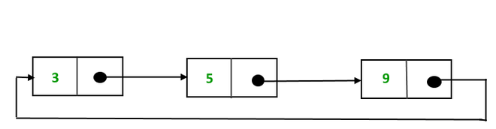

*Representation of Circular singly linked list*

* **Circular Doubly linked list:**Circular Doubly Linked List has properties of both doubly linked list and circular linked list in which two consecutive elements are linked or connected by the previous and next pointer and the last node points to the first node by the next pointer and also the first node points to the last node by the previous pointer.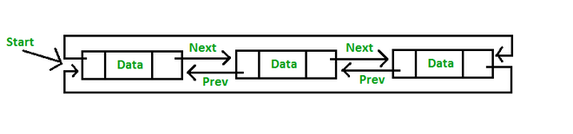

**Note:**We will be using the singly circular linked list to represent the working of the circular linked list.

**Representation of circular linked list:**

Circular linked lists are similar to single Linked Lists with the exception of connecting the last node to the first node.

Node representation of a Circular Linked List:

C++

// Class Node, similar to the linked list

class Node{

int value;

// Points to the next node.

Node next;

}

Example of Circular singly linked list:



*Example of  circular linked list*

The above  Circular singly linked list can be represented as:

C++

// Initialize the Nodes.

Node one = new Node(3);

Node two = new Node(5);

Node three = new Node(9);

// Connect nodes

one.next = two;

two.next = three;

three.next = one;

**Explanation:** In the above program one, two, and three are the node with values 3, 5, and 9 respectively which are connected in a circular manner as:

* **For Node One:**The Next pointer stores the address of Node two.
* **For Node Two:**The Next stores the address of Node three
* **For Node Three:** TheNext points to node one.